1. Create a simple cloud software application and provide it as a service using any Cloud Service Provider to demonstrate Software as a Service (SaaS).

# DATE:25/06/2025

AIM: To Create a simple cloud software application and provide it as a service using any Cloud Service Provider to demonstrate Software as a Service (SaaS).

# PROCEDURE:

**STEP 1:** GOTO ZOHO.COM

**STEP 2:** LOGIN TO THE ZOHO.COM **STEP 3:** SELECT ONE APPLICATION **STEP 4:** ENTER APPLICATION NAME

**STEP 5:** CREATED NEW APPLICATION

**STEP 6:** SELECT ONE FORM

**STEP 7:** THE SOFTWARE HAS BEEN CREATED.

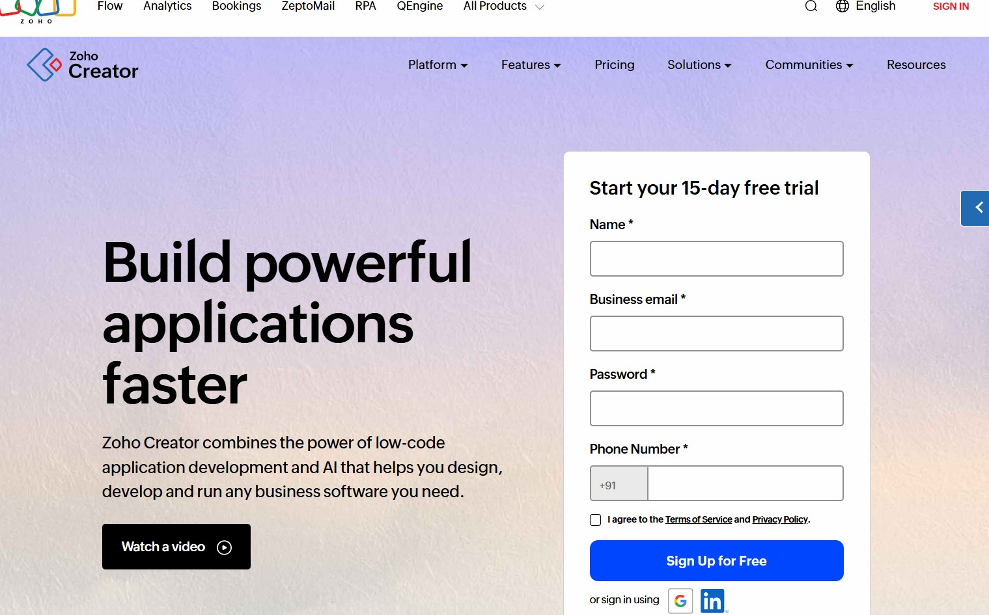**STEP 1:** GOTO ZOHO.COM

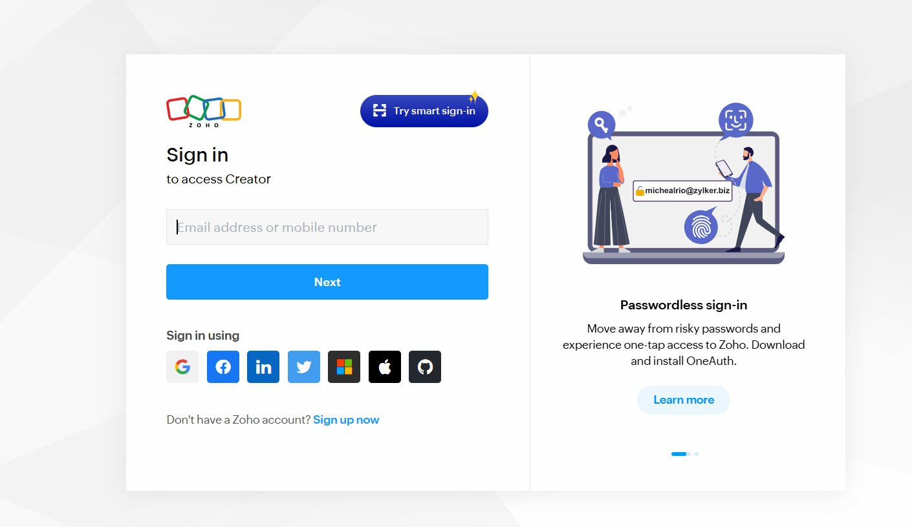**STEP 2:** LOGIN TO THE ZOHO.COM

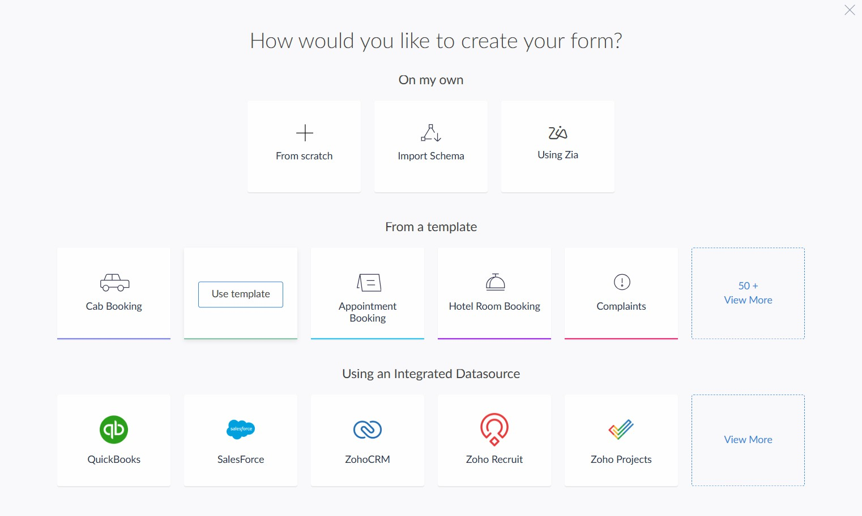**STEP 3:** SELECT ONE APPLICATION

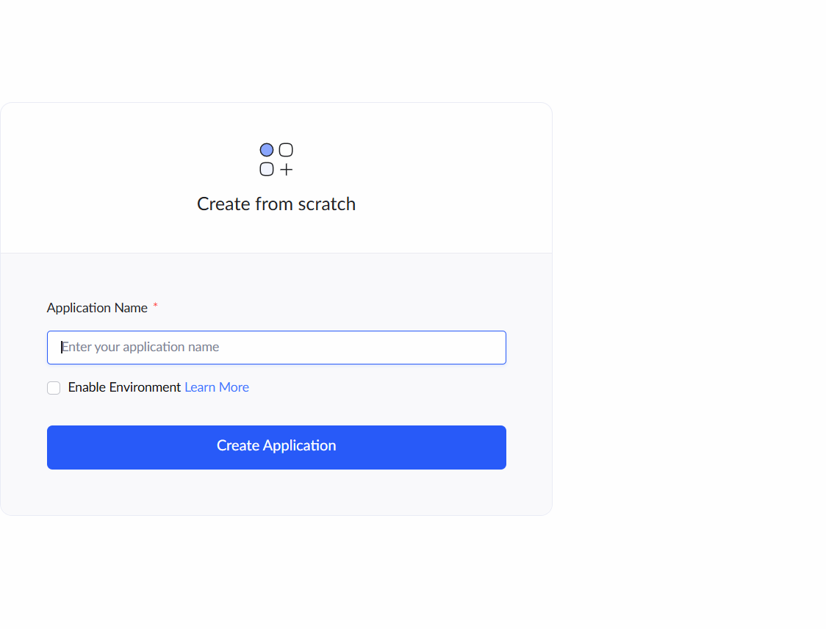**STEP 4:** ENTER APPLICATION NAME

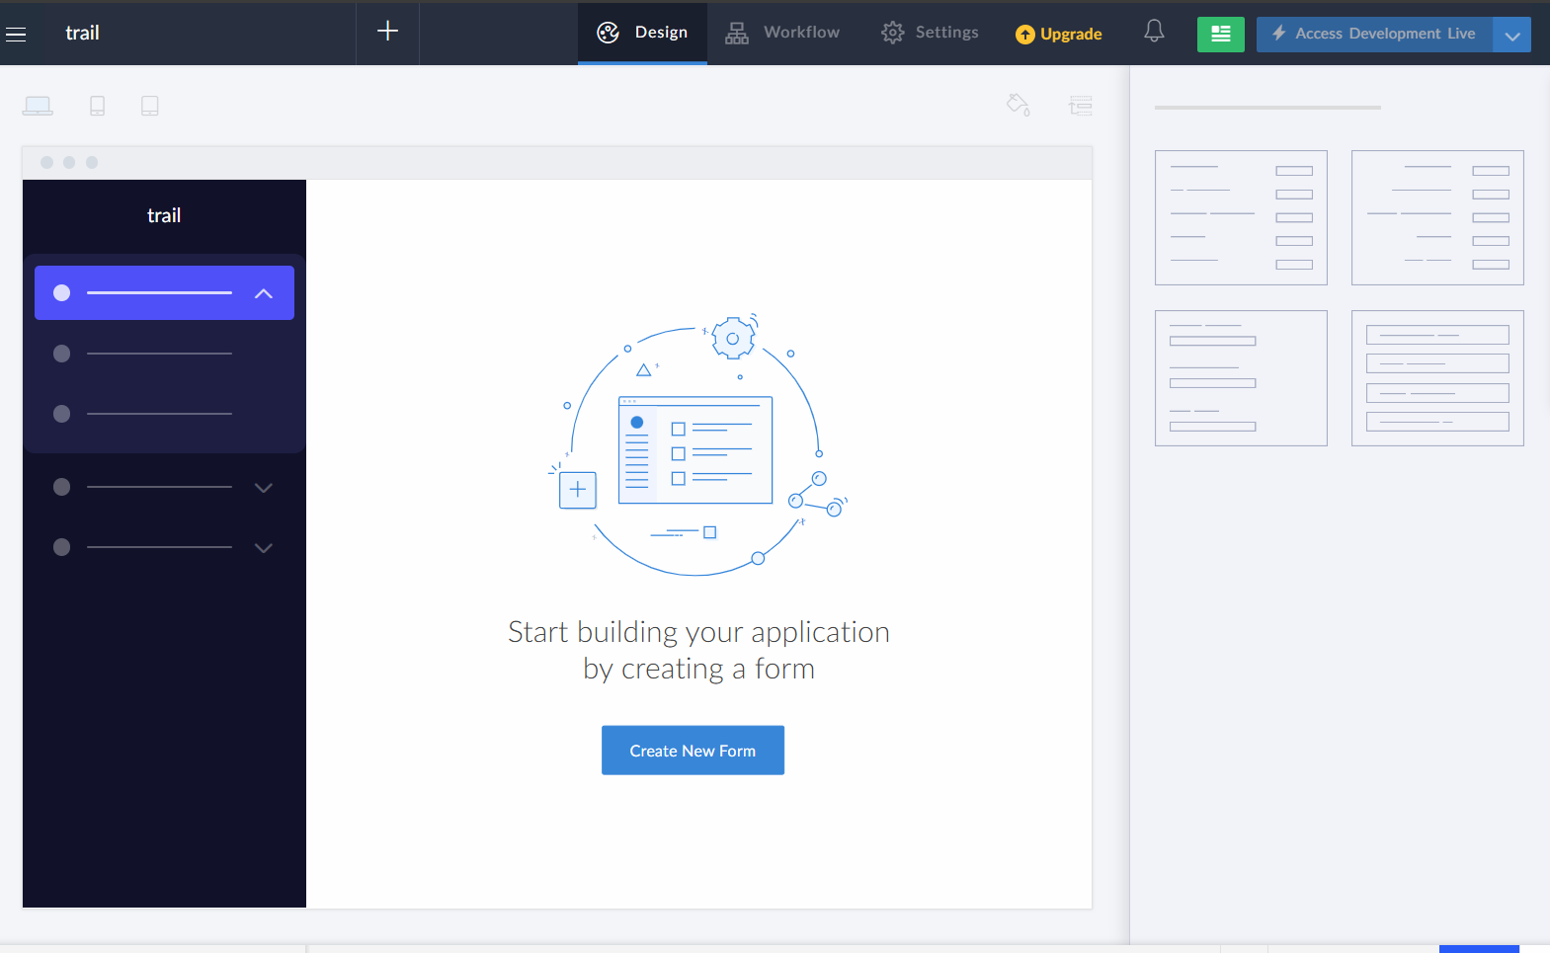**STEP 5:** CREATED NEW APPLICATION

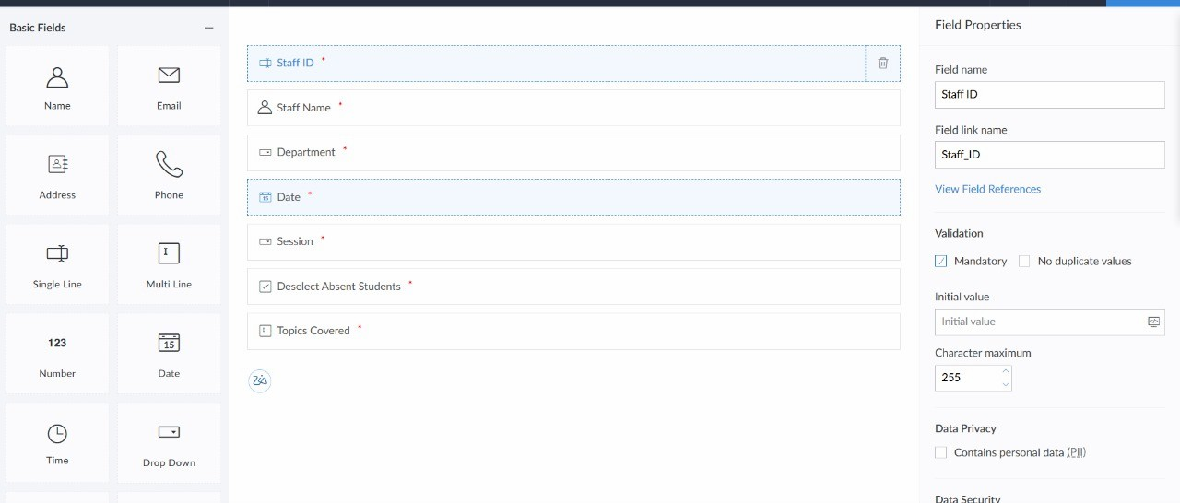**STEP 6:** SELECT ONE FORM

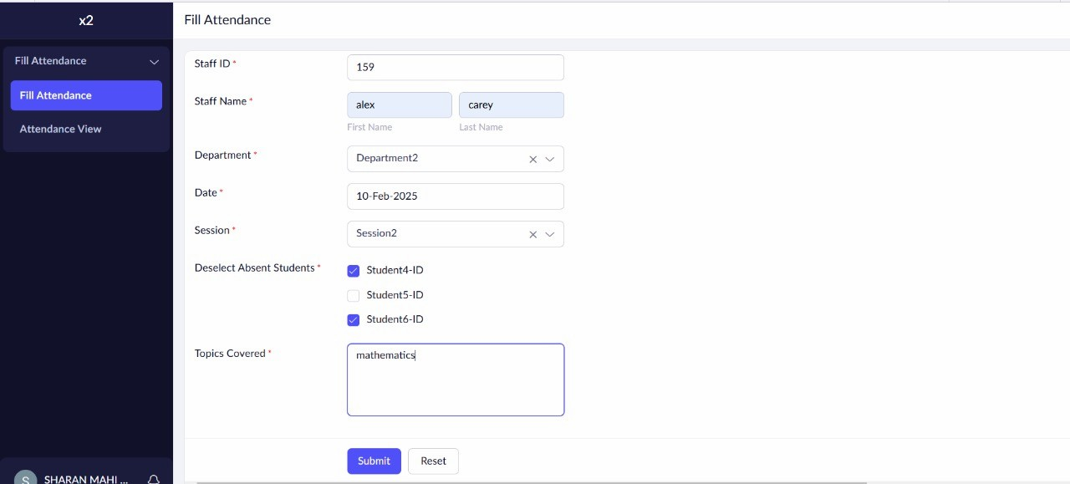**STEP 7:** THE SOFTWARE HAS BEEN CREATED.

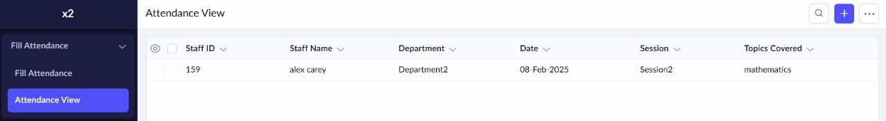OUTPUT (Student Attendance):

1. Create a simple cloud software application for Flight Reservation System using any Cloud Service Provider to demonstrate SaaS.

# DATE:25/06/2025

AIM: To Create a simple cloud software application for Flight Reservation System using any Cloud Service Provider to demonstrate SaaS.

# PROCEDURE:

**STEP 1:** GOTO ZOHO.COM

**STEP 2:** LOGIN TO THE ZOHO.COM **STEP 3:** SELECT ONE APPLICATION **STEP 4:** ENTER APPLICATION NAME

**STEP 5:** CREATED NEW APPLICATION

**STEP 6:** SELECT ONE FORM

**STEP 7:** THE SOFTWARE HAS BEEN CREATED.

**STEP 1:** GOTO ZOHO.COM

**STEP 2:** LOGIN TO THE ZOHO.COM

**STEP 3:** SELECT ONE APPLICATION

**STEP 4:** ENTER APPLICATION NAME

**STEP 5:** CREATED NEW APPLICATION

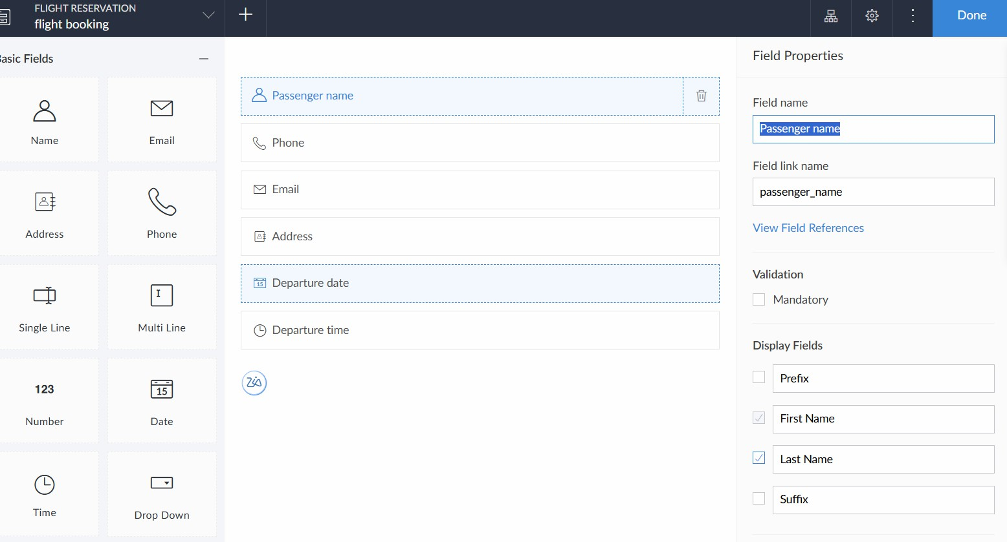**STEP 6:** SELECT ONE FORM

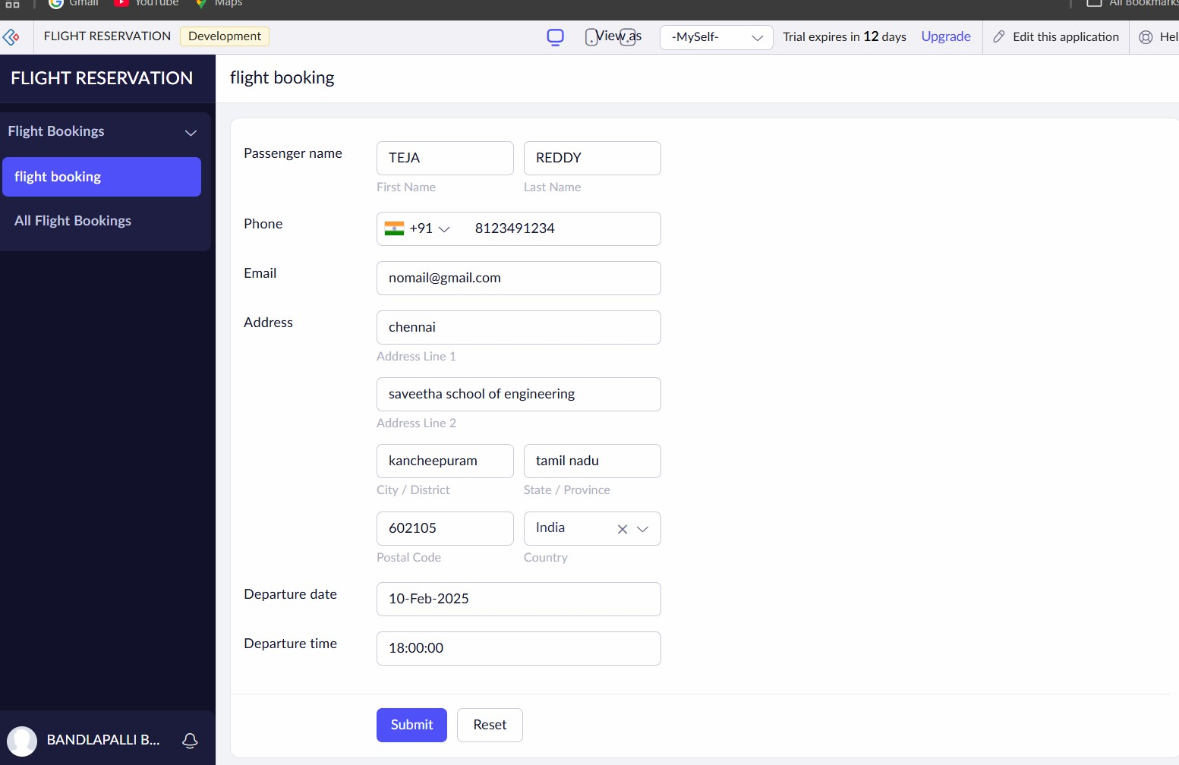**STEP 7:** THE SOFTWARE HAS BEEN CREATED.

# OUTPUT (FLIGHT RESERVATION):

1. Create a simple cloud software application for Property Buying & Rental process (In Chennai city) using any Cloud Service Provider to demonstrate SaaS.

AIM: To Create a simple cloud software application for Property Buying & Rental process using any Cloud Service Provider to demonstrate SaaS.

# PROCEDURE:

**STEP 1:** GOTO ZOHO.COM

**STEP 2:** LOGIN TO THE ZOHO.COM **STEP 3:** SELECT ONE APPLICATION **STEP 4:** ENTER APPLICATION NAME

**STEP 5:** CREATED NEW APPLICATION

**STEP 6:** SELECT ONE FORM

**STEP 7:** THE SOFTWARE HAS BEEN CREATED.

**STEP 1:** GOTO ZOHO.COM

**STEP 2:** LOGIN TO THE ZOHO.COM

**STEP 3:** SELECT ONE APPLICATION

**STEP 4:** ENTER APPLICATION NAME

**STEP 5:** CREATED NEW APPLICATION

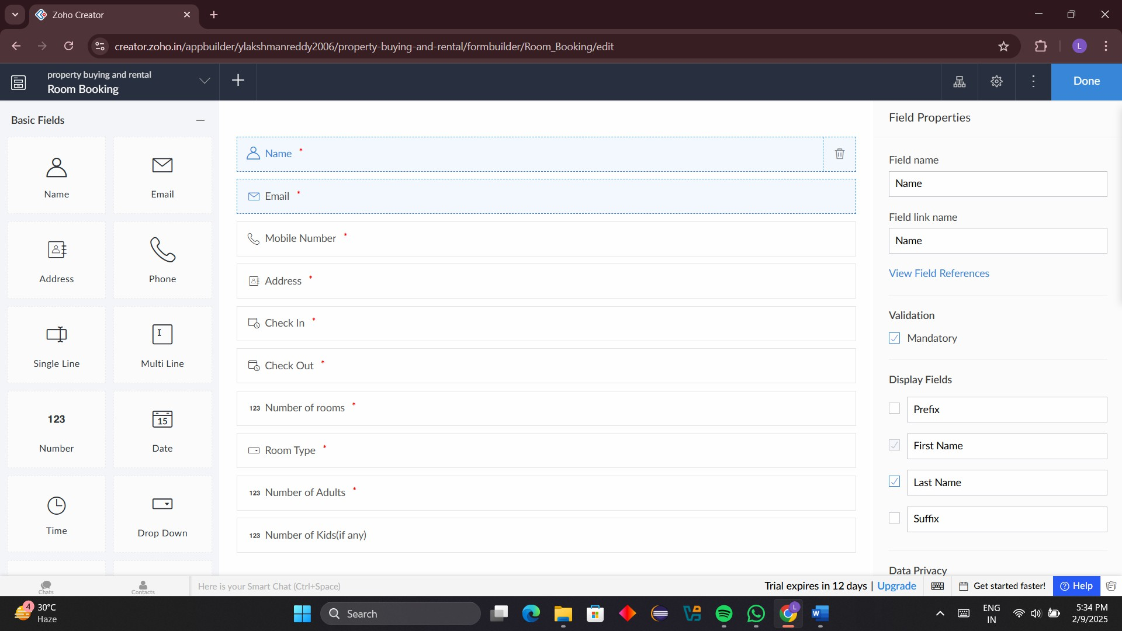**STEP 6:** SELECT ONE FORM

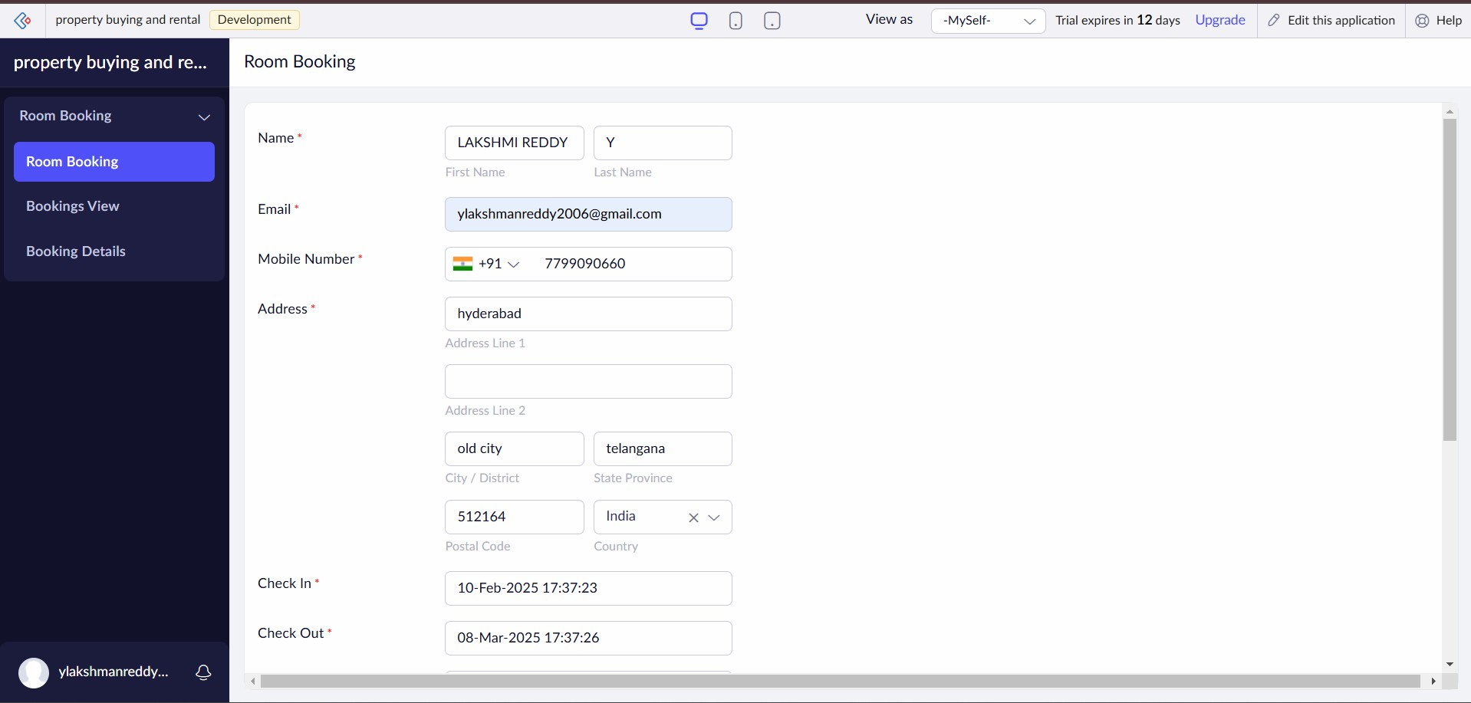**STEP 7:** THE SOFTWARE HAS BEEN CREATED.

# OUTPUT (PROPERTY RENTAL AND BUYING):

1. Create a simple cloud software application for Car Booking Reservation System using any Cloud Service Provider to demonstrate SaaS.

# DATE:25/06/2025

AIM: Create a simple cloud software application for Car Booking Reservation System using any Cloud Service Provider to demonstrate SaaS.

# PROCEDURE:

**STEP 1:** GOTO ZOHO.COM

**STEP 2:** LOGIN TO THE ZOHO.COM **STEP 3:** SELECT ONE APPLICATION **STEP 4:** ENTER APPLICATION NAME

**STEP 5:** CREATED NEW APPLICATION

**STEP 6:** SELECT ONE FORM

**STEP 7:** THE SOFTWARE HAS BEEN CREATED.

**STEP 1:** GOTO ZOHO.COM

**STEP 2:** LOGIN TO THE ZOHO.COM



**STEP 3:** SELECT ONE APPLICATION

**STEP 4:** ENTER APPLICATION NAME

**STEP 5:** CREATED NEW APPLICATION

**STEP 6:** SELECT ONE FORM

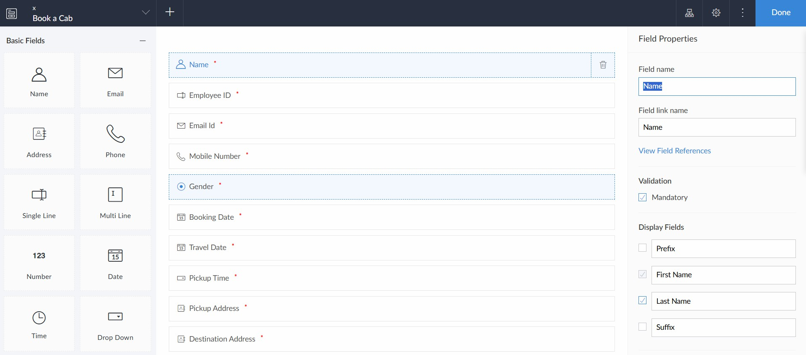

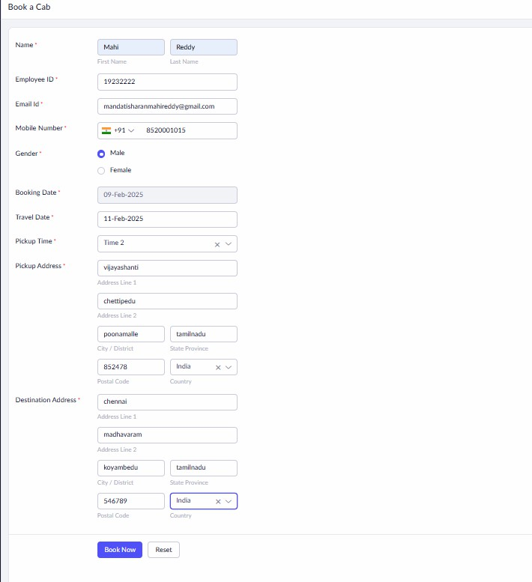**STEP 7:** THE SOFTWARE HAS BEEN CREATED.

# OUTPUT (CAR RESERVATION):

1. Create a simple cloud software application for Library book reservation system for SIMATS library using any Cloud Service Provider to demonstrate SaaS

Date :/06/2025

Aim: To Create a simple cloud software application for Library book reservation system for SIMATS library using any Cloud Service Provider to demonstrate SaaS

# PROCEDURE:

**STEP 1:** GOTO ZOHO.COM

**STEP 2:** LOGIN TO THE ZOHO.COM **STEP 3:** SELECT ONE APPLICATION **STEP 4:** ENTER APPLICATION NAME **STEP 5:** CREATED NEW APPLICATION **STEP 6:** SELECT ONE FORM

**STEP 7:** THE SOFTWARE HAS BEEN CREATED.

**STEP 1:** GOTO ZOHO.COM

**STEP 2:** LOGIN TO THE ZOHO.COM.



**STEP 3:** SELECT ONE APPLICATION

**STEP 4:** ENTER APPLICATION NAME

**STEP 5:** CREATED NEW APPLICATION

**STEP 6:** SELECT ONE FORM

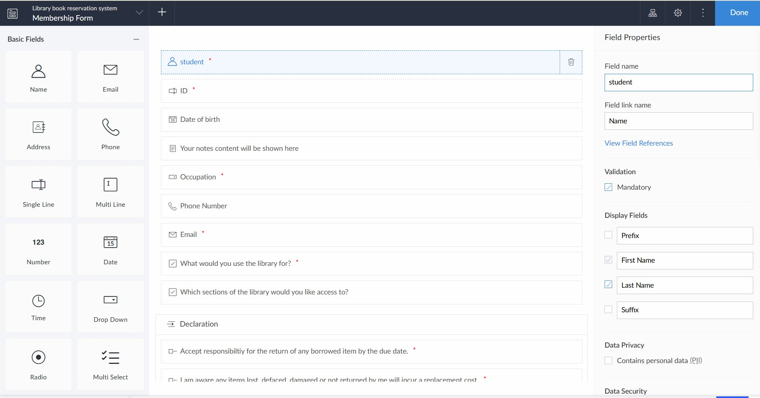

**STEP 7:** THE SOFTWARE HAS BEEN CREATED

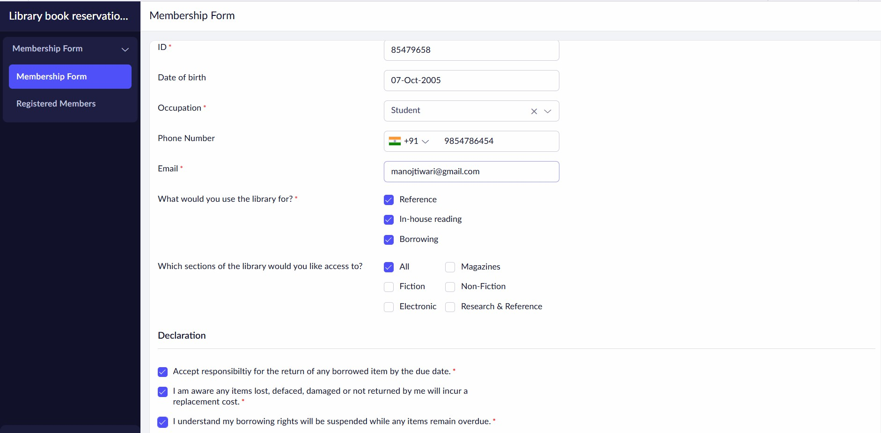

OUTPUT (library managent system):

